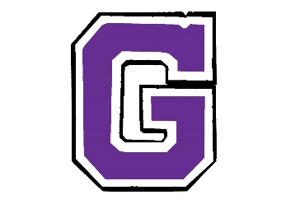
GOLDEN ISLES GYMNASTICS
www.goldenislesgym.com
(912) 280-0044
Cheerleading
Cheer Class: $68/month
Cheer Prep
Wed 5-6pm (8-16 yrs)

Tumbling
One class a week: $68/month

Tots Tumbling
Thur 4-5pm (5-7 yrs)
Beginner Tumbling
Mon or Wed 6-7pm (7-14 yrs)
Intermediate Tumbling
Mon 7-8pm (8-16 yrs)

Boys Classes
One class a week: $68/month
Ninja Training
Mon 4-5pm (4-6 yrs)
Wed 4-5pm (4-6 yrs)
Thur 5-6pm (4-6 yrs)
Iron Man
Mon 5-6pm (7-11 yrs)
Parkour
Tues 6-7pm (8+ yrs)

Gymnastics
One (1 hour) class a week: $68/month
Two (1 hour) classes a week: $110/month
One Gymstars (2 hour) class a week: $110/month

Preschool Classes
Mon 4-5pm (4-6 yrs)
Tues 4-5pm (5-7 yrs)
Tues 5-6pm (3-5 yrs)
Wed 5-6pm (4-6 yrs)

Rec Gymnastics
Mon 5-6pm (5-7 yrs)

Gymstars
Tues or Thurs 4-6pm (5-7 yrs)
Tues or Thurs 6-8pm (8+ yrs)

Home School
Mon 3-4pm (All Ages)

Open Gym
No Registration Fee For
Programs Listed Below

Mom’s Club
*4yrs and under preferred*
Mon & Wed 10:30-11:30am $8 per visit
Saturday Open Gym
*All Ages*
Saturday 10am-Noon
$10 per visit
Parkour and Open Gym
*8yrs and over preferred*
Friday 7-9pm
$10 per visit
Adult Open Gym
*16 and over only*
Wed 7-8pm
$10 per visit

Birthday Parties
Saturday or Sunday
12:30-2:00pm
2:30-4:00pm
4:30-6:00pm
6:30-8:00pm

Annual Membership Fee is $50
Payment is due BEFORE the first class of each month.
A Thirty Day written notice is needed when dropping a class!
Private Lessons: $60 per hour Semi-Private: 2 or 3 athletes $80 per hour
*Additional Party Times, School Field Trips, Teen Only Parties, and other Events available upon request*

